9. ReactJS-HOL
Creating React App : npx create-react-app cricketapp

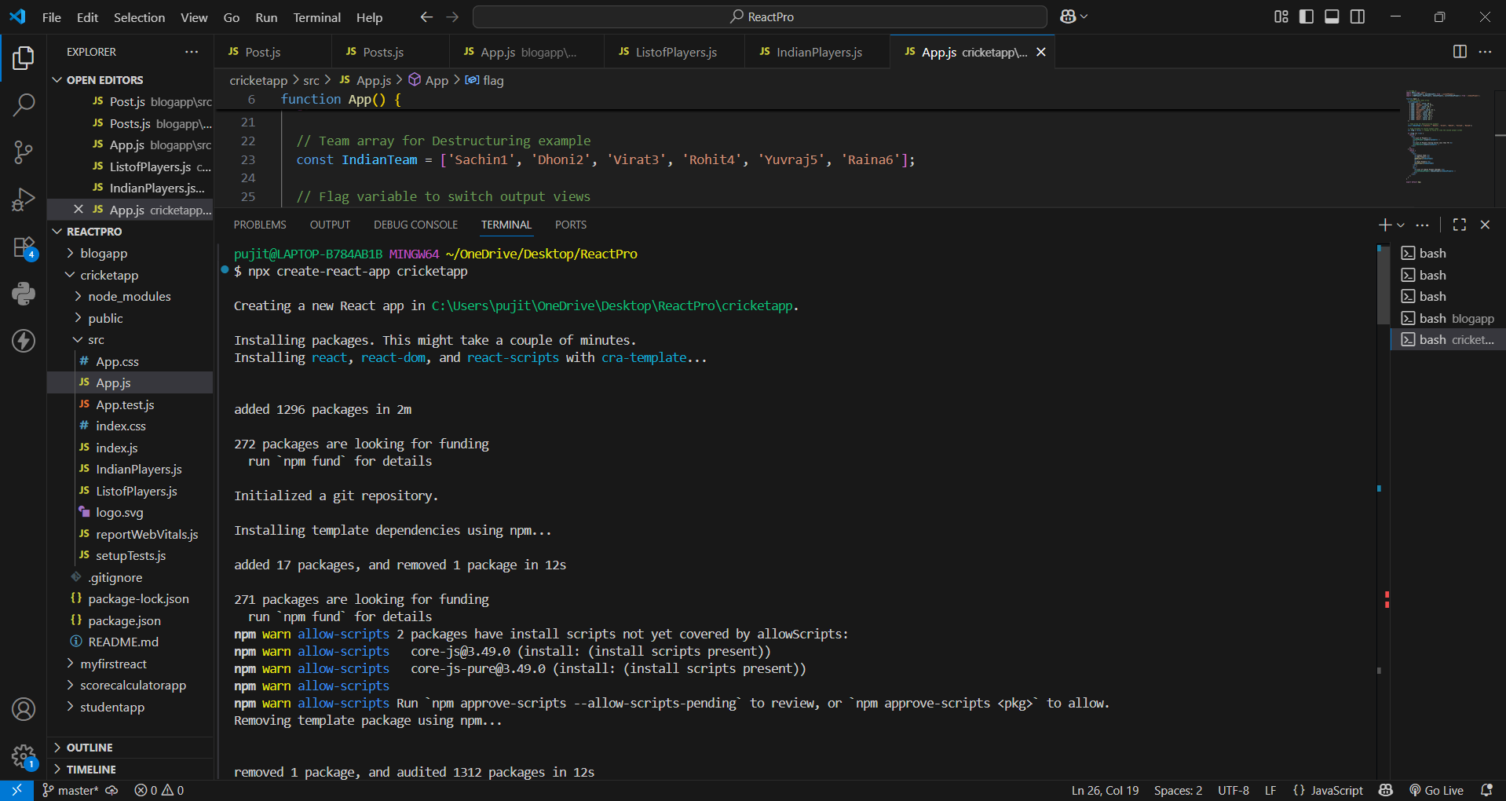
ListofPlayers.js:
import React from 'react';

// Component to render all players using Array.prototype.map()
export function ListofPlayers({ players }) {
return (
<div>
{players.map((item, index) => (
<div key={index}>
<li>Mr. {item.name} <span>{item.score}</span></li>
</div>
))}
</div>
);
}

// Component to render players with scores <= 70
export function Scorebelow70({ players }) {
const players70 = [];

// Filtering using map and arrow function as specified in the lab instructions
players.map((item) => {
if (item.score <= 70) {
players70.push(item);
}
return null;
});

return (
<div>
{players70.map((item, index) => (
<div key={index}>
<li>Mr. {item.name} <span>{item.score}</span></li>
</div>
))}
</div>
);
}
IndianPlayers.js:
import React from 'react';

// Destructuring odd positions: index 0 (first), 2 (third), 4 (fifth)
export function OddPlayers([first, , third, , fifth]) {
return (
<div>
<li>First : {first}</li>
<li>Third : {third}</li>
<li>Fifth : {fifth}</li>
</div>
);
}

// Destructuring even positions: index 1 (second), 3 (fourth), 5 (sixth)
export function EvenPlayers([, second, , fourth, , sixth]) {
return (
<div>
<li>Second : {second}</li>
<li>Fourth : {fourth}</li>
<li>Sixth : {sixth}</li>
</div>
);
}

// Declare two arrays and merge them using ES6 Spread Operator (...)
const T20Players = ['First Player', 'Second Player', 'Third Player'];
const RanjiTrophyPlayers = ['Fourth Player', 'Fifth Player', 'Sixth Player'];

export const IndianPlayers = [...T20Players, ...RanjiTrophyPlayers];

// Component to render the merged list of players
export function ListofIndianPlayers({ IndianPlayers }) {
return (
<div>
{IndianPlayers.map((player, index) => (
<div key={index}>
<li>Mr. {player}</li>
</div>
))}
</div>
);
}
App.js :
import React from 'react';
import { ListofPlayers, Scorebelow70 } from './ListofPlayers';
import { OddPlayers, EvenPlayers, IndianPlayers, ListofIndianPlayers } from './IndianPlayers';

function App() {
// Sample player data array
const players = [
{ name: 'Jack', score: 50 },
{ name: 'Michael', score: 70 },
{ name: 'John', score: 40 },
{ name: 'Ann', score: 61 },
{ name: 'Elisabeth', score: 61 },
{ name: 'Sachin', score: 95 },
{ name: 'Dhoni', score: 100 },
{ name: 'Virat', score: 84 },
{ name: 'Jadeja', score: 64 },
{ name: 'Raina', score: 75 },
{ name: 'Rohit', score: 80 }
];

// Team array for Destructuring example
const IndianTeam = ['Sachin1', 'Dhoni2', 'Virat3', 'Rohit4', 'Yuvraj5', 'Raina6'];

// Flag variable to switch output views
var flag = true; // Change to false to view the second output screen

if (flag === true) {
return (
<div>
<h1>List of Players</h1>
<ListofPlayers players={players} />
<hr />
<h1>List of Players having Scores Less than 70</h1>
<Scorebelow70 players={players} />
</div>
);
} else {
return (
<div>
<div>
<h1>Indian Team</h1>
<h1>Odd Players</h1>
{OddPlayers(IndianTeam)}
<hr />
<h1>Even Players</h1>
{EvenPlayers(IndianTeam)}
</div>
<hr />
<div>
<h1>List of Indian Players Merged:</h1>
<ListofIndianPlayers IndianPlayers={IndianPlayers} />
</div>
</div>
);
}
}

export default App;
Running on localhost 3000 :
When flag==true :
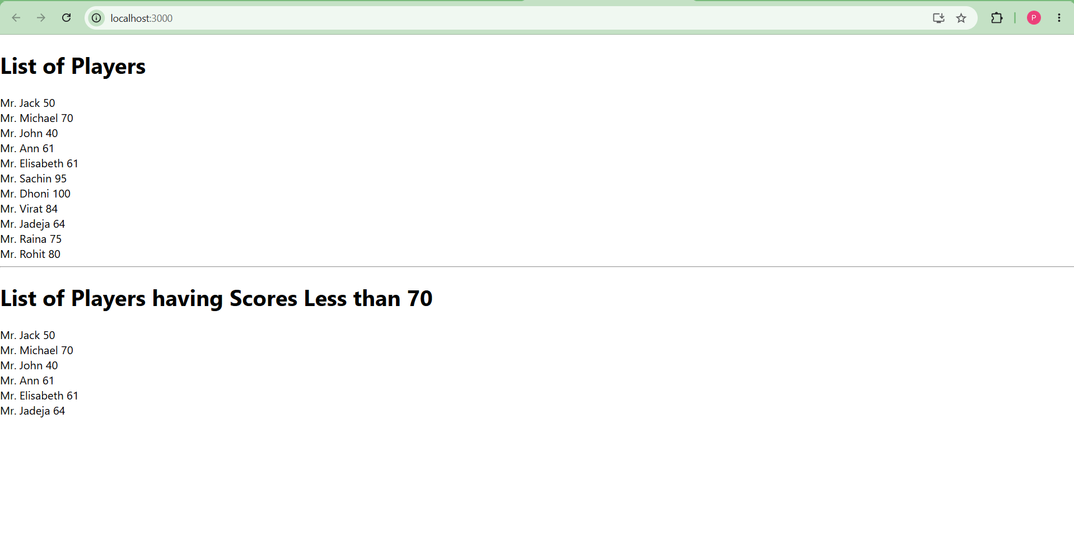
When flag==false:
